ImageList Control

1. Add an ImageList control to your form
2. Add two images in collections, one for the button's normal appearance and one for when the mouse is hovering over.
3. Change Image size

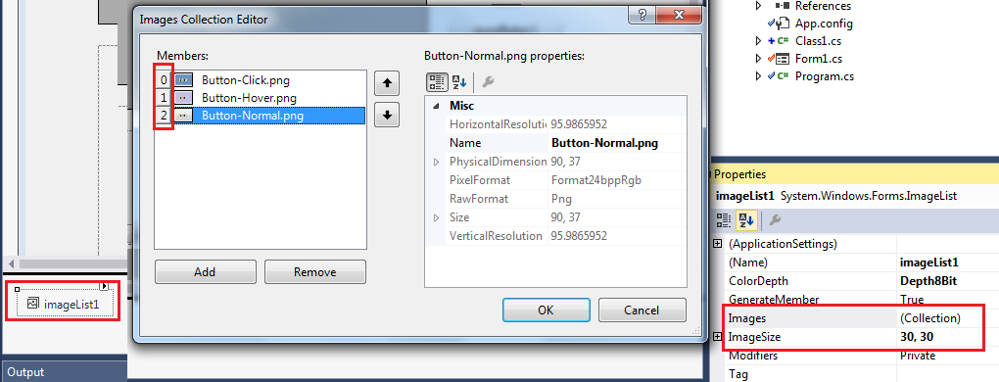

Button Control

1. Add your button and set the following properties:  
   FlatStyle = Flat  
   FlatAppearance.BorderColor (and maybe MouseOverBackColor & MouseDownBackColor) to your form's background color

Or change BorderSize = 0  
ImageList = the ImageList you added to the form  
ImageIndex to the index value of your normal image

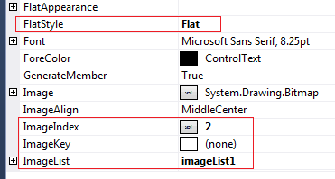

Code the MouseHover and MouseLeave events for the button like this:

private void button1_MouseHover(object sender, EventArgs e) {

    // ImageList index value for the hover image.

    button1.ImageIndex = 1;

}

private void button1_MouseLeave(object sender, EventArgs e) {

    // ImageList index value for the normal image.

    button1.ImageIndex = 0;

}

2260-0811 ENRIQUE

using System;

using System.Collections.Generic;

using System.ComponentModel;

using System.Data;

using System.Drawing;

using System.Linq;

using System.Runtime.InteropServices;

using System.Text;

using System.Threading.Tasks;

using System.Windows.Forms;

namespace UI

{

public partial class Form1 : Form

{

private MyCustomDataGridView dgGrid1 = new MyCustomDataGridView();

public Form1()

{

InitializeComponent();

}

private void Form1_Load(object sender, EventArgs e)

{

SetupDataGridView();

}

private void SetupDataGridView()

{

this.Controls.Add(dgGrid1);

dgGrid1.ColumnCount = 5;

dgGrid1.ColumnHeadersDefaultCellStyle.BackColor = Color.Navy;

dgGrid1.ColumnHeadersDefaultCellStyle.ForeColor = Color.White;

dgGrid1.ColumnHeadersDefaultCellStyle.Font = new Font(dgGrid1.Font, FontStyle.Bold);

dgGrid1.Name = "dgGrid1";

dgGrid1.Location = new System.Drawing.Point(74, 15);

dgGrid1.Size = new System.Drawing.Size(600, 150);

dgGrid1.AutoSizeRowsMode = DataGridViewAutoSizeRowsMode.DisplayedCellsExceptHeaders;

dgGrid1.ColumnHeadersBorderStyle = DataGridViewHeaderBorderStyle.Single;

dgGrid1.CellBorderStyle = DataGridViewCellBorderStyle.Single;

dgGrid1.GridColor = Color.Black;

dgGrid1.RowHeadersVisible = true;

dgGrid1.Columns[0].Name = "Period";

dgGrid1.Columns[1].Name = "Total";

dgGrid1.Columns[2].Name = "Payment";

dgGrid1.Columns[3].Name = "Amount";

dgGrid1.Columns[4].Name = "Method";

dgGrid1.Columns[4].DefaultCellStyle.Font = new Font(dgGrid1.DefaultCellStyle.Font, FontStyle.Italic);

dgGrid1.SelectionMode = DataGridViewSelectionMode.FullRowSelect;

dgGrid1.MultiSelect = false;

dgGrid1.Dock = DockStyle.Fill;

}

}

public partial class MyCustomDataGridView : DataGridView

{

public MyCustomDataGridView()

: base()

{

Region = System.Drawing.Region.FromHrgn(CreateRoundRectRgn(0, 0, Width - 10, Height - 10, 20, 20));

}

[DllImport("Gdi32.dll", EntryPoint = "CreateRoundRectRgn")]

private static extern IntPtr CreateRoundRectRgn(

int nLeftRect, // x-coordinate of upper-left corner

int nTopRect, // y-coordinate of upper-left corner

int nRightRect, // x-coordinate of lower-right corner

int nBottomRect, // y-coordinate of lower-right corner

int nWidthEllipse, // height of ellipse

int nHeightEllipse // width of ellipse

);

}

}